Platonic Representation Hypothesis
(by M. Huh, B. Cheung, T. Wang and P. Isola)

- Introduction
  - Neural networks, trained with different objectives on different data and modalities, are converging to a shared statistical model of reality in their representation spaces.
  - There exists a real world (Z), which we measure with various sensors such as the camera (X) and text (Y). Representation learning algorithms find vector embeddings that statistically model the various measurements and projections. The resulting vector embeddings are derived from the reality Z and are thereby aligned. As models are trained on more data and for more tasks, they require representations that capture more and more information about Z, and hence alignment toward Z increases toward a convergent point as a function of scale.
  - This converged hypothetical representation is called the “platonic representation” in reference to Plato’s Allegory of the Cave, and his ideal reality that underlies our sensations. The training data for our algorithms are shadows on the cave wall, yet we hypothesize, models are recovering ever better representations of the actual world outside the cave.
  - Closely related is the “Anna Karenina scenario” referring to the possibility that all well-performing neural nets represent the world in the same way. The platonic representation hypothesis refers to the situation where we are in an Anna Karenina scenario and the “happy representation” that is converged upon is one that reflects a statistical model of the underlying reality.

- Representations are converging
  - We focus on representations that are vector embeddings. They are characterized by the similarity structure it induces, referred to as its kernel. We define representational alignment as a measure of the similarity of the similarity structures induced by two representations i.e., a similarity metric over kernels. We give the mathematical definition of these concepts below:
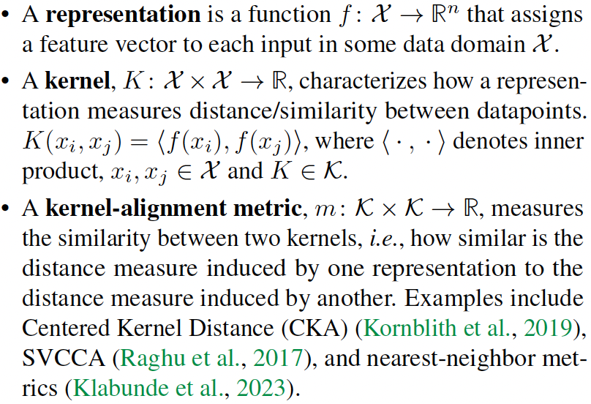
  - Different models, with different architectures and objectives, can have aligned representations.
  - Alignment increases with scale and performance. The discussion so far indicates that various models are aligning toward a unified representation. But does the convergence extend to model weights? While models with different architectures might not have compatible weight spaces, there exists ample evidence that models with the same architecture will often converge to the same basin of weights.
Because of this, it is possible to merge separately trained models of the same architecture and achieve some of the capabilities of all models in the mixture.
  - Representations are converging across all modalities. the better an LLM is at language modeling, the more it tends to align with vision models. The converse also holds, the better a vision model is, the more it tends to align with LLMs.
  - Models are increasingly aligning to brains. Neural networks show substantial alignment with biological representations in the brain. This commonality may be due to similarities in the task and data constraints both systems are confronted with. Even though the mediums may differ – silicon transistors versus biological neurons – the fundamental problem faced by brains and machines is the same: efficiently extracting and understanding the underlying structure in images, text, sounds, etc. The tasks that the human visual system performs like segmentation, detection and whole-image classification are also the ones that neural nets are trained to perform. Performance over such tasks implies brain alignment.
Psychophysical studies have also shown agreement between how humans perceive visual similarity and how models do, even when the models are trained on tasks, such as self-supervised prediction, that are seemingly unrelated to mimicking human perception.
  - Does alignment predict downstream performance? If models are converging towards a more accurate representation of reality, we expect that alignment should correspond to improved performance on downstream tasks. This hypothesis is supported by demonstrating improved performance on commonsense reasoning and mathematical problem solving as alignment improves.

- Why are representation converging?
  - Modern machine learning models are trained to minimize the empirical risk with possible implicit and/or explicit regularization:
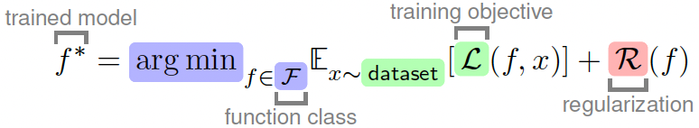
  - The Multitask Scaling Hypothesis: there are fewer representations that are competent for N tasks than there are for M<N tasks. As we train more general models that solve more tasks at once, we should expect fewer possible solutions.
Simply put it means that the set of solutions to an easy goal is large, while the set of solutions to a challenging goal is comparatively smaller.
Recent work has demonstrated a power law relationship between data scale and model performance, implying that with enough data one ought to converge to a very small solution set with irreducible error.
  - The Capacity Hypothesis: bigger models are more likely to converge to a shared representation than smaller models.
  - It is not unreasonable to posit that the representations used to detect a dog in a 1M parameter model could be quite different than that used by a 1B parameter model. What would stop a billion-parameter (and counting) model from learning an overly complicated and distinct representation? One key factor might be simplicity bias.
The Simplicity Bias Hypothesis: deep networks are biased toward finding simple fits to the data, and the bigger the model, the stronger the bias. Therefore, as models get bigger, we should expect convergence to a smaller solution space.
Such simplicity bias could be coming from explicit regularization

- What representations are we converging to?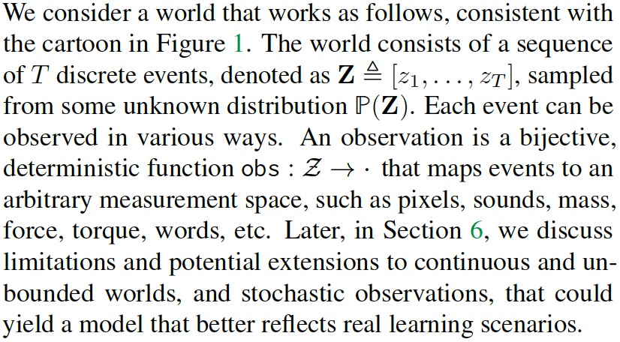
  - Models trained on different modalities — for example text, images, audio, or other observations — may eventually learn similar internal representations because all these modalities are generated from the same underlying world.
They call this underlying world something like Z.
  - They discuss contrastive learning, where a model learns by comparing:
    - Positive pairs: things that occur together or are related.
    - Negative pairs: things that are unrelated or randomly sampled.
    - Example:
      - Image of a dog + caption “a dog running” = positive pair.
      - Image of a dog + caption “stock market chart” = negative pair.
    - The model learns embeddings where related things are close together and unrelated things are far apart.
  - Language models can learn relationships between colors from text co-occurrence. For example, words like “red,” “orange,” and “yellow” may occur in similar contexts, while “black” and “white” have different relationships.
The paper says these learned color distances in language can mirror human perception of color.
This supports their claim that even text-only models can learn structures that reflect real-world perception.

- What are the implications of convergence?
  - Scaling is sufficient, but not necessarily efficient
  - Training data can be shared across modalities. Suppose you have access to N images and M sentences and want to learn the best representation. If there is indeed a modality-agnostic platonic representation, then both image and language data should help find it. The implication is that if you want to train the best vision model, you should train not just on N images but also on M sentences. This is already becoming common practice.
OpenAI showed that training on images improved performance on text. In theory, there should be some conversion ratio: a pixel is worth a words for training LLMs, and a word is worth b pixels for training vision models.
  - Scaling may reduce hallucination and bias. A prominent shortcoming of current LLMs is their propensity to hallucinate or output false statements. If models are indeed converging toward an accurate model of reality, and scale powers this convergence, then we may expect hallucinations to decrease with scale. Of course, our hypothesis is conditioned on the training data for future models constituting a sufficiently lossless and diverse set of measurements. This may not come to pass, but it is an implication of our hypothesis worth pointing out. A similar argument can be made about certain kinds of bias. It has been shown that large models can exacerbate existing biases present in their training data. Our hypothesis implies that, while this may be true, we should expect larger models to amplify bias less. This does not mean bias will be removed, rather that the model’s biases will more accurately reflect the data’s biases, rather than exacerbating them.

